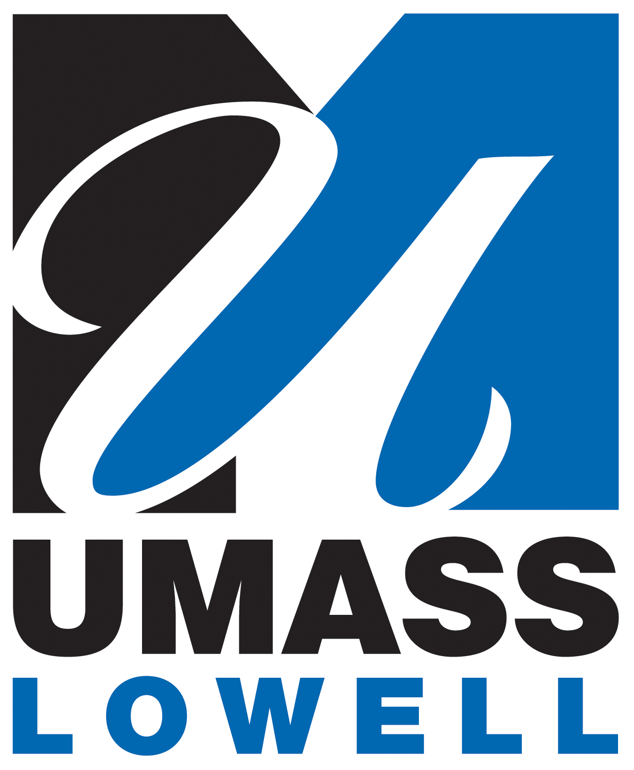
Logo of partner
School here

Memorandum of Understanding

Between

The University of Massachusetts Lowell

And

XXXXXXXXXXXXXXXXX

This Memorandum of Understanding (MOU) is entered into by and between the University of Massachusetts Lowell (UML) and XXXXXXXXXXX (XXX). UML and XXX agree that cooperation in research collaborations and student and faculty exchanges would be mutually beneficial. The areas of cooperation may include, subject to mutual consent, any desirable and feasible activity that would further the goals of each institution. Such interaction may include cooperation in a variety of joint academic and education activities such as:

- Joint research projects and publications, including work by undergraduate, graduate, and post-doctoral students at the partner institutions;
- Joint degree programs;
- Faculty and student exchanges;
- Reciprocal placement of students in paid internships and co-ops, when possible;
- Joint conferences and workshops;
- Team taught courses, including online courses; and
- Visits by faculty, professional staff, and students.
We anticipate that a number of these initiatives will occur during the period of this MOU. In particular, based on previous conversations, the following initiatives provide a good starting place and can be put into place as soon as administrative details can be worked out between the two universities: [Note: The items below should be adapted to fit the partner institution or to reflect previous conversations if there has been earlier discussion.]

- Summer joint MBA electives;
- Summer undergraduate experiences;
- Faculty and student exchanges and opportunities for paid internships;
- Joint degree programs;
- Cooperation in academic and research programs in nanotechnology and bioengineering centers, including the joint Ph.D. program in Biomedical Engineering and Biotechnology between UMass Lowell and UMass Medical School and the joint Massachusetts Center for Medical Devices.

In addition, UMass Lowell will be pleased to facilitate relationships between XXXXXXXXXXX and other institutions in the University System of Massachusetts: UMass Amherst, UMass Boston, UMass Dartmouth and the UMass Medical School in Worcester. [Note: This paragraph should be deleted for any schools that fall under an existing MOU with the University System.]


Cooperation in Education and Research

In order to facilitate student exchanges between XXXXXXXXXXXXXXXXX and the University of Massachusetts Lowell, the following section provides specific procedural information under which the exchange of students between the two institutions will take place.

Cooperation and exchanges may take place with undergraduate, graduate, or post-doctoral students. Each exchange may be for the duration of one academic year, one academic semester, or one intensive course, normally four-weeks in length, scheduled either between academic terms or during the summer.

Whenever possible, courses will be team taught by one faculty member from XXX and one faculty member from UML. Courses may be taught at UML, at XXX, or concurrently at both campuses through online capabilities.

Students may engage in paid co-op or paid internship opportunities through placements by the host university, providing they meet the legal criteria of the host country.

[Note: International students studying in the United States must comply with U.S. immigration regulations. Typically, U.S. Immigration law requires that an international student maintain full-time status, prohibits them from taking more than one on-line course per semester, and imposes restrictions on off-campus employment. More flexibility is granted to graduate students visiting the U.S. for the purpose of research towards the completion of a thesis/dissertation in their home countries. International students studying in the United States will be required to purchase health insurance to meet certain standards such as medical evacuation and repatriation of remains.]

If two faculty members from each institution are engaged in collaborative research projects, doctoral students at one institution may visit and work in the lab of the faculty member at the other institution and incorporate the work done as part of their dissertation research. When connected to funded research projects, the host university will endeavor to provide a stipend for the visiting doctoral student.

Responsibilities of home institution for academic semester or academic year exchanges:

The home institution will:

- Register its own students for the duration of the exchange.
- Submit to the host institution the names and academic credentials of students who would like to participate in an exchange.
- Provide the host institution with names of courses that are essential to their own students’ curricular plan.
- Ask the student to advise the host institution of any circumstances that may affect his or her year abroad (e.g. medical condition, disability status).
- Advise its students about academic and cultural expectations at the host university.

Responsibilities of the host institution for academic semester or academic year exchanges:

The host institution will:

- Be responsible for admission decisions of students recommended by the home institution.
- Provide an orientation program for incoming students.
- Endeavor to ensure that students are admitted to courses regarded as essential to their academic programs at their home institutions.
- Assign an academic advisor to all incoming students.
- Assist the incoming student in securing housing.
- Inform the incoming student of health insurance requirements.
- Provide the home institution with a final transcript of the student’s academic performance.

Costs to be borne by the student for academic semester or academic year exchanges:

Students will bear the cost of:

- Tuition and fees to their home university prior to participation in the program.
- Room and board at the host university.
- Their own health insurance and any medical bills or non-mandatory fees.
- Books, living expenses, and any other costs relating to the exchange.
- Transportation to and from the host institution.

Four-week intensive courses:

Four week intensive courses, offered during the summer or between semesters, will be taught by a UMass Lowell faculty member. Students will pay a flat fee for the course and that fee will include:

- Airfare to and from the host country from the United States;
- Transportation within the host country;
- Accommodation in the host country;
- Any additional fees charged by the host institution.

The total cost of each course will differ according to the location of the host country and the nature of the course being taught.

Students will bear the cost of:

- Their own health insurance and any medical bills or non-mandatory fees;
- Food, living expenses, and any other costs relating to the exchange;
- Books and necessary academic supplies necessary for the course.

Normally, each student may receive up to 9 hours of credit for the successful completion of the four-week intensive course. Each course will have 25-30 students.



The primary contacts for this MOU are NAME for XXXXXXXXXXXXXXXXXXXX and Provost Ahmed Abdelal for the University of Massachusetts Lowell. The parties may enter into specific written agreements whenever appropriate to clarify and define the nature, extent, and terms of operation for the proposed collaborations, including intellectual property ownership and funding issues. Any agreement entered into by these two universities will require the approval of appropriate officers from each institution. All agreements and activities covered under this MOU or entered into by the parties must comply with all applicable laws and regulations, including all U.S. and Xxxxxxxx export control laws and regulations.

For agreed upon activities, both institutions will make available their facilities and staffs. This MOU will be valid for five (5) years unless terminated by one of the parties. Either institution may withdraw from this MOU provided written notification of the withdrawal is given to the other institution at least three (3) months prior to the desired withdrawal date. This MOU may be renewed for another period of five (5) years upon mutual written consent of the two institutions before the expiration date. This MOU is made in both English and Xxxxxxxx and each institution will have copies of the agreement in both languages. This MOU will take effect on the date the signatures of the university officials are affixed to this document.

The following authorized individuals have signed the present MOU on behalf of their respective institutions:

____________________________________ ________________________________
Name Ahmed Abdelal
Title Provost
University University of Massachusetts Lowell

____________________________________ ________________________________
Date Date



